Aengus Kennedy

2025 04 18

Tufts ME0134

Lab 3

**Experiment 1: 100-cm line and return**

The robot was instructed to drive forward 10 seconds at 10 cm/s, turn 180 degrees, and then drive back.

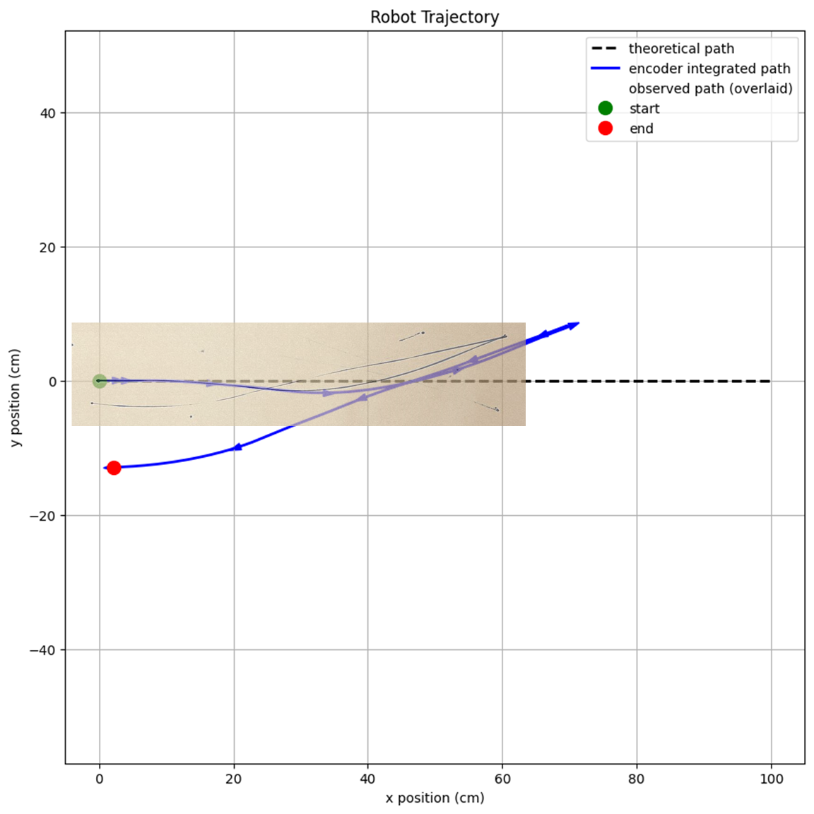

**Experiment 2: 50-cm line and curve**

The robot was instructed to drive forward 5 seconds at 10 cm/s and then drive in a quarter circular arc to the left with radius 8 cm.

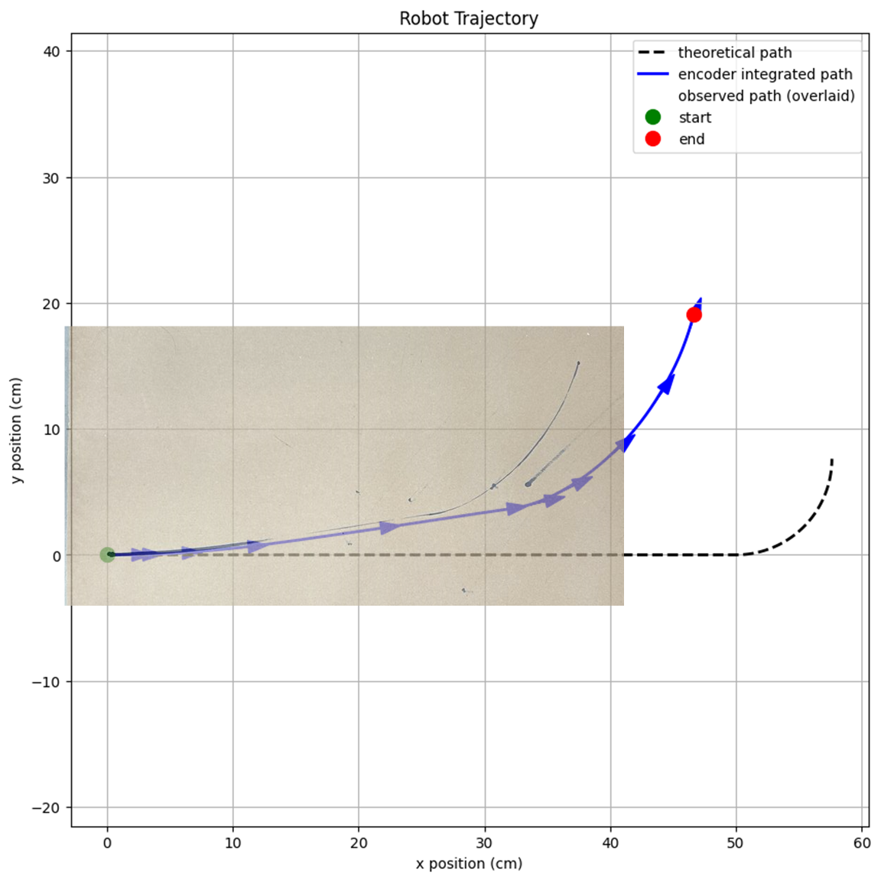

**Experiment 3: 20-cm circle**

The robot was instructed to drive in a circle with v_l = 0.6 cm/s and v_r = 4.5 cm/s so that one revolution would take 30 seconds. Its track diameter is 15.24 cm. These wheel speeds were chosen so that the robot would trace a circle of radius 20 cm, as expressed by the equation

The robot ended up drawing a circle significantly larger in radius than 20 cm, which I would expect to have been a result of the motors’ weak performance at low speeds. When instructed to drive slowly, the XRP’s motors’ PI controllers tend to start the motors at an effort value so small that they barely move until the integral term catches up enough to increase the effort enough to drive forward. If this happened to the slow left motor but not to the fast right motor, it could explain why the robot did not make the predictable circular path that it was instructed to.

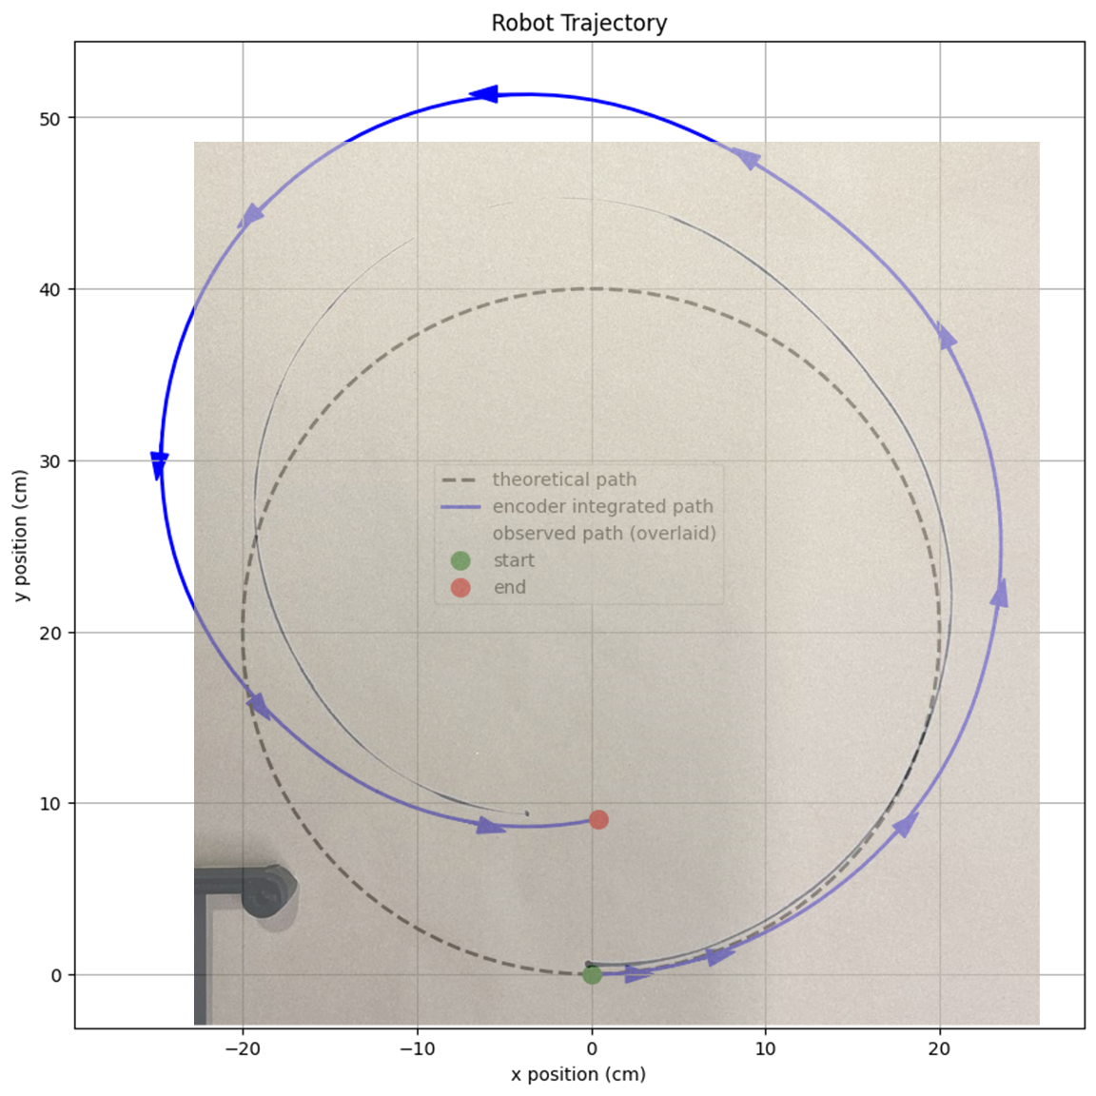

**Experiment 4: circle with incorrect wheel track diameter**

The forward kinematics of experiment 3 was redone with the wheel track diameter falsely set to 20 cm instead of 15.24cm. The result is that both the theoretical circular path and the forward kinematics integrated path are much larger than the path the robot actually traversed. This is because when a robot is wider, the same difference between its left wheel velocity and its right wheel velocity will correspond to smaller rotation and more translation. This fact also follows from the equation , in which it can be seen that increasing the robot’s track diameter *d* proportionally increases *R_ICC*.

Parameters such as wheel track diameter are important in forward kinematics because every small step in the integration of the robot’s position depends on them, so small changes in them can result in great changes in prediction because error accumulates throughout the integration.

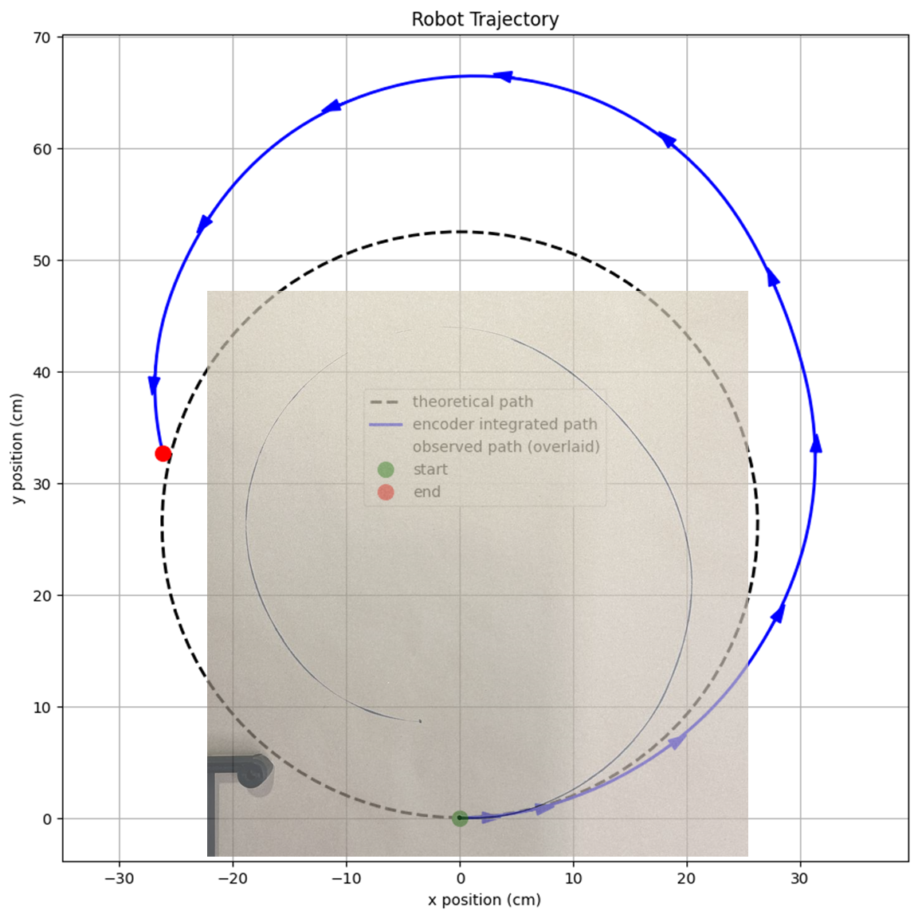

**Analysis**

Because determining the position of a robot using only wheel encoders is prone to errors, it is common to use more sensors than just encoders to keep track of a robot’s position, and this sensor information is processed and filtered. Several kinds of sensors beyond encoders are valuable for processing, including IMUs, cameras that recognize visual markers, and GPS sensors. The information from these sensors can be integrated together or with encoder data in several ways, including by using a Kalman filter or by Monte Carlo/particle filter localization.